Luis Bautista
August 22, 2016
Period 6
Asteroid
1 Asteroid is a rocky or metallic object smaller than a planet that orbits a star. Astronomers have discovered asteroid belts around other stars. This article, however, will discuss asteroids in our own solar system.
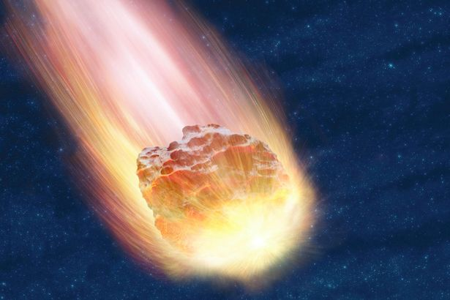
Most asteroids orbit the sun between the orbits of Mars and Jupiter. This region is known as the Main Belt. Millions of asteroids may exist. Astronomers think that most of them measure less than 6 miles (10 kilometers) in diameter. The majority of asteroids have a rocky composition. Some consist of metal or a mixture of metal and rock.

People sometimes call the asteroids minor planets. That term has no formal definition in astronomy, however. The International Astronomical Union (IAU) is a widely recognized authority in naming heavenly bodies. According to the IAU, no asteroid is large enough to be considered a planet. The IAU classifies Ceres, the largest asteroid, as a dwarf planet.

Scientists think that asteroids consist of material left over from the formation of the solar system. Such processes as erosion and volcanic activity have altered the planets and moons. But much of the material in asteroids is almost unchanged. Much of our knowledge of asteroids comes from studying meteorites, pieces of matter that have fallen to Earth from asteroids.

2 Sizes and shapes.
Ceres’s longest diameter measures 605 miles (975 kilometers). Ceres makes up more than one-fourth of the total mass (amount of matter) of the Main Belt asteroids. The next largest asteroids are Pallas and Vesta. Each stretches slightly over 300 miles (500 kilometers) in diameter. The tiniest asteroids may be pebble-sized. They would be too small to be seen by Earth-based telescopes.

Occasionally, a large asteroid will break apart into many smaller ones, usually as the result of a collision. For this reason, smaller asteroids are far more common than larger ones. Astronomers estimate that only about 1,000 Main Belt asteroids have diameters of over 18 miles (30 kilometers).

Asteroids have a variety of shapes. A large object’s gravitational pull tends to press its mass into a ball. The largest asteroids, therefore, appear roughly spherical. Smaller asteroids have gravitational pulls that are too weak to greatly alter their shapes. They tend to take on irregular, elongated (long and thin) forms. The Main Belt asteroid Kleopatra, for example, has a “dog bone” shape. It looks like two rounded knobs connected by a thin center. Kleopatra measures about 135 miles (217 kilometers) long and 58 miles (94 kilometers) wide.
3C-type asteroids
make up about 75 percent of all known asteroids. They have a rocky composition. The asteroids appear darker than coal. In fact, they resemble a group of carbon-rich meteorites known as carbonaceous chondrites. C-type asteroids have a chemical composition similar to that of the sun. However, they lack the lightest elements, hydrogen and helium.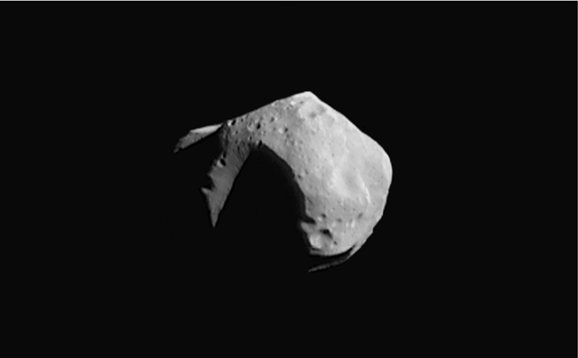
4 S-type asteroids.
Scientists classify roughly 15 percent of asteroids as S-type asteroids. These asteroids are bright rocky bodies that also contain some metal. The metal is an alloy (mixture) of nickel and iron called nickel-iron. S-type asteroids consist of nickel-iron and silicates (rock-forming compounds) of iron and magnesium.
5 Composition.
Astronomers analyze the light that asteroids reflect to determine the objects’ composition. This technique is called spectroscopy. They also study meteorites thought to be fragments of asteroid material. Astronomers have identified several distinct classes of asteroids. Most asteroids belong to one of three major types—C-type, S-type, and M-type.
6 M-type asteroids.

Most of the remaining asteroids belong to the third major group, the M-type asteroids. These bright objects consist of nearly pure nickel-iron. They may be fragments of the metallic core of a larger body that broke apart.

Other asteroid types are relatively rare. One such group, the D-type asteroids, occurs more frequently in the outer solar system. They appear more unchanged than asteroids of the inner solar system. The sun's heat has modified the compositions of the asteroids in the inner solar system.

This text was taken from: http://www.worldbookonline.com/student/article?id=ar034580&st=asteroids

